DGOP Workflow Engine

Detailed System Design and Operations Guide

STATUS  Engineering Baseline |  | OWNER  DGOP Product & Engineering |  | LAST UPDATED  July 29, 2026

Authors | Codex, acting as senior software engineer documentation support
Reviewers | DGOP product owner, senior data governance lead, senior backend engineer, security reviewer
Related docs | apps/api/src/workflow/*.ts; apps/api/prisma/schema.prisma; apps/web/src/app/pages/governance/workflow/*; apps/api/test/workflow.service.spec.ts
Scope | Explains the DGOP Workflow Engine architecture, BPMN designer, runtime execution, tasks, approvals, SLA, delegations, DMN-style gateway rules, evidence and form validation, security, auditability, operations, and known boundaries.

1. Abstract
The DGOP Workflow Engine is the execution layer that turns governance policy into governed work. It is not only a task list. It defines reusable workflow routes, parses and validates BPMN-compatible models, opens cases, assigns tasks, records decisions, enforces evidence and form requirements, routes cases through stages, handles sequential and parallel approval patterns, tracks SLA risk, stores runtime tokens, preserves version snapshots, and exposes dashboards and visual route maps for nontechnical operators.
The engine is implemented natively inside DGOP using Angular for the workbench, NestJS for guarded API endpoints, Prisma for durable workflow state, and PostgreSQL for transactional persistence. It supports BPMN import/export, a business-friendly route designer, publish readiness checks, simulation, migration preview, version diff, rollback, active-case migration, task decisions, form submission, comments, attachments, delegations, SLA templates, graph visualization, and 60-second dashboard refresh data.
Important implementation note: DGOP currently implements a native BPMN-compatible workflow runtime. It is not an external Camunda Zeebe cluster. The BPMN XML is used as a model contract and designer interchange format, while DGOP's service layer executes the state machine, approvals, gates, and domain-specific side effects.

2. Goals and Non-Goals
Goal | What this means in DGOP | Non-goal or boundary
Executable governance routes | Every major governance process can be represented as a route template with stages, transitions, roles, due days, evidence, forms, notifications, and automation metadata. | DGOP does not rely on informal notes or disconnected spreadsheet approvals as the source of truth.
Enterprise validation before execution | Routes must have start and final stages, valid transitions, reachable nodes, assigned human roles, explicit decisions, and publish-safety checks. | Invalid BPMN should not be published just because it renders visually.
Task and case runtime | Cases produce assigned tasks, task decisions advance the route, and the case keeps status, events, comments, attachments, runtime tokens, and linked domain records. | The engine is not a static diagram viewer.
Nontechnical operation | The UI exposes Route Map, My Tasks, Cases, and BPMN Designer views so business users can see where work sits and what is blocking it. | The UI should not require users to understand raw XML or internal database state.
Audit and migration safety | Published route versions are signed, stored, diffed, and migration-previewed before active cases are moved. | A new route version should not silently strand open work.
Governance domain integration | Ownership, DQ, security, privacy, FOI, sharing, open data, NDI, and other modules can create or update workflow cases. | The workflow engine does not replace those domain engines; it orchestrates their decisions and evidence.

3. Conceptual Model
The Workflow Engine has three layers. The definition layer stores templates, stages, transitions, BPMN XML, designer JSON, validation output, signatures, and versions. The runtime layer stores workflow cases, tasks, events, comments, attachments, SLA state, delegation outcomes, and runtime tokens. The operations layer exposes route maps, personal task queues, case views, dashboard analytics, migration tools, and the BPMN designer.

Core workflow concepts
Concept | Purpose | Stored as | Why it matters
Workflow template | Reusable route for one case type, such as data quality issue, FOI request, privacy breach, owner approval, or data sharing request. | WorkflowTemplate | Defines the governing path before any case is opened.
Stage | A human task, review, approval, information step, service task, gateway, or closure stage. | WorkflowTemplateStage | Controls ownership, SLA, validation requirements, routing behavior, and what the operator sees.
Transition | Allowed movement from one stage to another, optionally tied to approval/rejection, labels, expressions, or condition JSON. | WorkflowTemplateTransition | Prevents cases from jumping into undefined states.
BPMN XML | Import/export and visual model representation of the route. | WorkflowTemplate.bpmnXml and WorkflowTemplateVersion.bpmnXml | Keeps the workflow model portable and reviewable.
Designer JSON | Parsed route summary used by UI and validation previews. | WorkflowTemplate.designerJson | Allows a business-friendly designer response without reparsing everything in the UI.
Workflow case | Runtime instance of a governance process. | WorkflowCase | Connects the route to an asset, assignment, quality issue, privacy record, sharing request, FOI request, and other domain records.
Workflow task | Actionable unit assigned to a user or role queue. | WorkflowTask | Where decisions, due dates, forms, decisions, and SLA status live.
Runtime token | Execution marker for active stage/task movement, including parallel or sequential approval state. | WorkflowRuntimeToken | Gives the native runtime a durable execution trace beyond only completed tasks.
Event | Audit-oriented case/task movement record. | WorkflowEvent | Explains who changed what, from which status, to which status, and why.
Comment and attachment | Collaborative and evidence artifacts linked to a case or task. | WorkflowTaskComment and WorkflowTaskAttachment | Supports defensible reviews and evidence requirements.

Supported case statuses and task statuses
Status family | Values | Operational meaning
CaseStatus | draft, submitted, under_review, awaiting_information, decision_made, approved, rejected, implemented, closed | Represents the end-to-end lifecycle of a governance case from creation through review, outcome, implementation, and closure.
TaskStatus | pending, in_progress, completed, cancelled | Represents whether an individual task is waiting, being worked, done, or no longer required.
TaskDecision | approved, rejected | Decision payload used by the task decision endpoint and route transition logic.
WorkflowDelegationStatus | pending, active, paused, expired, revoked | Controls whether delegated assignment is available for task routing.
WorkflowAttachmentKind | evidence, decision_note, supporting_document | Classifies files attached to workflow cases and tasks.
WorkflowSlaBreachPolicy | notify, escalate, block | Describes how SLA breach templates should behave.

4. Runtime Architecture
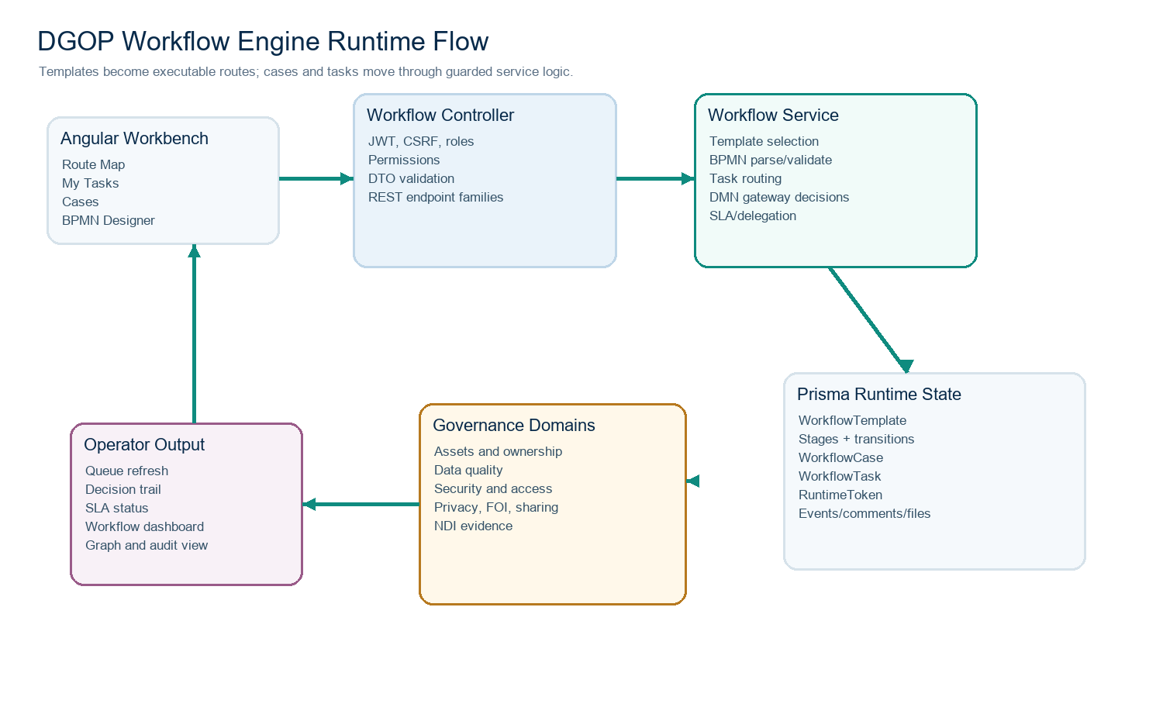
Figure 1. DGOP Workflow Engine runtime architecture.

Layer responsibilities
Layer | Runtime responsibility | Primary code evidence
Angular workflow workbench | Loads templates, graph, dashboard, tasks, cases, route previews, designer data, versions, diffs, simulations, migration previews, and task decisions. | apps/web/src/app/pages/governance/workflow/workflow.ts and workflow.types.ts
WorkflowController | Declares REST endpoints, permission guards, DTO contracts, task routes, case routes, template designer routes, dashboard routes, delegation routes, SLA routes, and maintenance route. | apps/api/src/workflow/workflow.controller.ts
WorkflowService | Owns the runtime behavior: template selection, visibility checks, case/task creation, decision handling, route advancement, migration, signing, SLA calculation, delegations, and domain side effects. | apps/api/src/workflow/workflow.service.ts
BPMN parser and validator | Converts template stages to BPMN XML, parses imported BPMN, validates reachability and publish safety, and simulates route execution. | apps/api/src/workflow/workflow.bpmn.ts
Workflow logic helpers | Provides default templates, case type registry, SLA templates, route candidate selection, DMN decision table evaluation, form schema validation, route diffing, and health scoring. | apps/api/src/workflow/workflow.logic.ts
Prisma data model | Stores definitions, versions, stages, transitions, cases, tasks, runtime tokens, events, comments, attachments, delegations, and SLA templates. | apps/api/prisma/schema.prisma
Domain engines | Create workflow cases and receive side effects for ownership, data quality, security, privacy, FOI, data sharing, open data, NDI, metadata, architecture, glossary, lineage, lifecycle, BIA, and compliance calendar work. | WorkflowCase relations in Prisma and domain services under apps/api/src

5. Route Definition and BPMN Designer
Routes begin as workflow templates. A template has a stable code, case type, English and Arabic names, trigger, optional data domain, default SLA days, BPMN XML, designer JSON, version number, publish metadata, signature metadata, and active/deleted state. Each template owns stages and transitions. The designer can create a route, import BPMN, save a draft, publish the route, run simulation, view migration impact, inspect versions, diff a version, rollback, and migrate active cases.

Designer operations
Operation | Endpoint | What happens
List templates | GET /api/workflow/templates | Returns templates visible to the current user, including stages, transitions, domain, and case counts.
Create route | POST /api/workflow/templates | Creates a designer route from supplied code/case type/name or initial stages. The service parses BPMN if supplied, validates it, signs version 1, and stores stages/transitions.
Open designer | GET /api/workflow/templates/:id/designer | Returns the template, BPMN XML, validation result, version metadata, security metadata, and enterprise readiness summary.
Save draft | POST /api/workflow/templates/:id/designer/save | Parses BPMN, validates, stores XML and designer JSON, but does not publish as the active executable version.
Publish | POST /api/workflow/templates/:id/designer/publish | Requires admin/editor permission, no validation errors, migration preview review, signature creation, version snapshot, published route application, and active-case migration.
Simulate | POST /api/workflow/templates/:id/designer/simulate | Runs a bounded route walkthrough using selected decisions and returns path, task count, decision points, evidence count, notification count, automation count, warnings, and blockers.
Migration preview | POST /api/workflow/templates/:id/designer/migration-preview | Compares current route to candidate route and lists added/retired stages, transition changes, active cases, manual-review cases, and risk level.
Versions | GET /api/workflow/templates/:id/designer/versions | Returns immutable versions with signature verification status, algorithm, security metadata, author, and timestamp.
Version diff | GET /api/workflow/templates/:id/designer/versions/:version/diff | Returns added/removed/changed stages and transitions between current and selected version.
Rollback | POST /api/workflow/templates/:id/designer/rollback | Restores a previous version by creating a new signed version and migrating active cases safely.
Migrate active cases | POST /api/workflow/templates/:id/designer/migrate-active-cases | Moves active cases onto the current published route when migration is possible; manual review cases remain explicit.

BPMN model semantics
BPMN element | DGOP mapping | Validation focus
task / userTask / manualTask | Human task stage with task type approval, review, or information. | Requires stable code/name, role assignment unless deliberately non-actionable, due days, and reachable path.
serviceTask / businessRuleTask / scriptTask / sendTask / receiveTask | Automated node with automation configuration. | Warns if automation configuration is missing.
exclusiveGateway / parallelGateway / inclusiveGateway / eventBasedGateway | Routing or decision stage. | Warns if branch rules, rejection/rework path, or duplicate branch labels are missing.
sequenceFlow | WorkflowTemplateTransition between stages. | Rejects unknown endpoints and self-transitions; warns for missing readable labels or duplicates.
DGOP custom attributes | Codes, node type, task type, assignment strategy, role, due days, forms, SLA, notifications, evidence, automation, gateway config. | Converted into stage/transition metadata and used by runtime checks.

Route validation checklist
Rule area | Hard error examples | Warning examples
Route shape | No stages, duplicate stage code, missing start, missing final, unreachable stage, stage cannot reach final. | Final stage has outgoing transition; route has low publish-readiness score.
Stage identity | Missing stable code or readable name, unsupported node type, unsupported task type. | Labels may be too technical for nontechnical users.
Assignments | Actionable human stage has no responsible role. | Role assignment coverage is incomplete across the route.
SLA | Due days are invalid or outside allowed range. | SLA config is sparse or not aligned with stage criticality.
Decisions | Transitions point to unknown stages or loop into themselves. | Decision stage lacks explicit branches, rejection/rework route, or duplicate branch labels.
Forms and evidence | Required form schema is invalid when submitted at runtime. | Information/intake stages lack forms; approval stages lack evidence requirements.
Automation and notifications | Unsupported automation type when executed in service logic. | Automated stage missing automation config; notification rules missing.

6. Case and Task Runtime
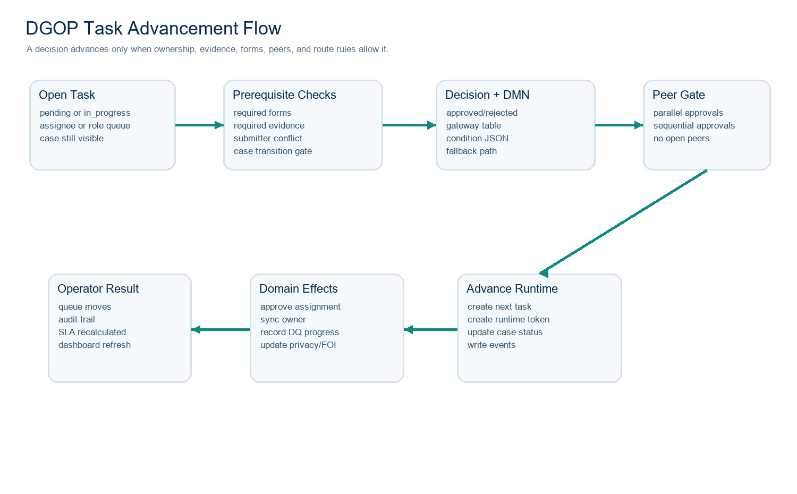
Figure 2. DGOP task advancement and route gate flow.
Runtime execution begins when a case is created or an existing domain action opens a routed case. The service resolves the best template by explicit template ID, matching case type, domain-specific route, or general fallback. It then creates a workflow case, opens the first actionable stage, creates the first task, computes due dates, records runtime tokens, and writes events. The same runtime is used whether the case came from the workflow page, ownership approval, data quality issue, DLP incident, classification change, privacy work, FOI request, data sharing request, or open data approval.

Case creation and routing sequence
Step | Service behavior | Integrity guard
Create request | Controller receives `CreateCaseDto` with title, description, type, templateId, and assetId. | DTO validates required fields and known case type.
User and scope | Service asserts user identity and verifies asset visibility where an asset is linked. | Data-scope and permission checks fail closed.
Template resolution | Service chooses explicit template, domain route, type route, or general governance review route. | Inactive or invisible templates are rejected.
Case insert | A code is generated and WorkflowCase is persisted with draft/submitted lifecycle state. | Prisma transaction keeps case and first task consistent.
First actionable stage | The route opens at the first human actionable stage or follows pass-through routing until one is found. | Unroutable cases are surfaced by maintenance and dashboard signals.
Task creation | Task is assigned to a direct user or role queue, due date is derived, and runtime token is created. | Role existence and delegation checks are applied.
Events | WorkflowEvent rows record submission, task creation, decisions, route movement, migration, or maintenance action. | Events create a reconstructable operating history.

Task decision sequence
- The user chooses approve or reject from the task queue, case detail page, or domain page that owns the work.
- The service confirms the task is open, belongs to a visible case, and is assigned to the current user, the user's role queue, or an allowed admin path.
- If the task stage has a form schema, the submitted data is validated for required fields, expected type, dates, and allowed values.
- If the stage requires evidence, attachments or decision comments must satisfy the evidence rule before approval can proceed.
- The service enforces domain-specific prerequisites, such as preventing assignment submitters from approving their own ownership change.
- The task is marked completed, decision/comment/form data are persisted, active runtime tokens are completed, and domain side effects are applied.
- The engine selects the next transition by DMN decision table, condition JSON, decision value, happy path, or default transition.
- If peer tasks are still open in a parallel approval group, advancement is blocked until the route gate is ready.
- If sequential approvals remain, the next approval task is created for the next role instead of closing the route.
- If the next node is automated or a pass-through gateway, the engine advances through bounded recursion until a human task or final state is reached.

7. Approvals, Forms, Evidence, SLA, and Delegation

Approval execution modes
Mode | How it works | When to use
Single approval | One role or user receives one task. A decision selects the next transition. | Simple owner review, steward check, or officer decision.
Parallel approval | Multiple approval tasks are created with one approval group. The route waits until open peer tasks are completed or cancelled. | Security, privacy, legal, and technical reviews that can run at the same time.
Sequential approval | The engine creates the first approval task, then creates the next role's task after the prior one completes. | Hierarchical sign-off where later reviewers must see earlier outcomes.
Gateway decision | A stage can evaluate decision tables and condition JSON before selecting a target transition. | Risk score branching, priority routing, rejection paths, and rework loops.

Form and evidence controls
Control | Runtime behavior | Operator impact
Reusable form schema | Schema fields and required arrays are validated by `validateWorkflowFormData` before form submission or decision. | Users get blocked early if required structured information is missing.
Evidence requirements | Stages can define required evidence items; approval can be blocked until attachments or comments satisfy the requirement. | Approvers cannot approve critical work without defensible proof.
Decision comments | When evidence names or form schema are not enough, the engine can require the decision comment to explain the decision. | Nontechnical operators get a place to explain the reason in plain language.
Attachment kinds | Files can be categorized as evidence, decision note, or supporting document. | Auditors can understand what kind of proof was attached.
Comments | Case and task comments support public/internal collaboration. | Teams can discuss cases without leaving the governed record.

SLA and delegation
- Stage due dates are derived from template stage due days, template default SLA days, or SLA templates.
- SLA templates define target business days, warning threshold, escalation threshold, breach policy, target role, and calendar code.
- Task rows are decorated with SLA status such as on track, at risk, overdue, done, or none for UI chips and dashboard analytics.
- Delegations can move work from one user to another for a role, asset, date window, and reason.
- Delegation status can be pending, active, paused, expired, or revoked; active delegations are considered when choosing an assignee.
- The workflow dashboard aggregates open tasks, overdue work, bottlenecks, assignee workload, trend data, average completion hours, and SLA compliance rate with a 60-second refresh contract.

8. Versioning, Migration, Signing, and Security
Publishing a workflow route is treated as an enterprise model change. DGOP signs model snapshots, stores immutable versions, validates route safety, compares route changes, previews active-case migration, and records the publishing action. This matters because active governance cases may already be sitting at stages that could be removed, renamed, or re-routed by a designer change.

Version and publish safety
Capability | Behavior | Protection provided
Signed model snapshot | The service signs the canonical workflow model with HMAC-SHA256 using `DGOP_BPMN_SIGNING_SECRET` or secure fallback rules. | Detects tampering and supports version trust checks.
Encrypted snapshot metadata | Published version records can store encrypted snapshot JSON and security metadata. | Keeps sensitive model details protected in version records.
Validation before publish | Publish rejects routes with validation errors and surfaces warnings/checklist results. | Blocks non-executable diagrams from becoming runtime routes.
Migration preview | Compares active cases and stage changes before publishing or migration. | Prevents silently stranding open tasks on retired stages.
Version diff | Shows added, removed, and changed stages and transitions. | Allows senior reviewers to understand route impact quickly.
Rollback | Creates a new version from a previous snapshot and migrates active cases according to current migration rules. | Makes recovery explicit and auditable.
Active-case migration | Moves cases when safe and identifies manual-review cases when not safe. | Protects in-flight governance work from broken route changes.

Authorization and visibility
- Workflow routes and cases are behind authenticated API endpoints and permission keys such as workflow case view/create/edit and workflow task view/edit.
- Case visibility is scoped by role, assigned user, asset visibility, role queues, and domain relationships.
- Task decisions require the task to be open and visible to the actor, with assignment checks for user ownership, role queue access, or approved admin paths.
- Linked assets are validated through the data asset scope model so scoped users cannot create or operate out-of-scope cases.
- The UI only exposes case creation, designer controls, and edit actions when the current user has the required permission.

9. Workflow UI and Operator Experience
The workflow UI is designed as an operations workbench. It has tabs for Route Map, My Tasks, Cases, and BPMN Designer. The Route Map presents templates, stages, domains, and active cases as a readable operating graph. My Tasks focuses on work assigned to the signed-in user or their role queue. Cases expose searchable workflow records and case details. The BPMN Designer gives administrators a safer way to create, inspect, simulate, publish, rollback, and migrate routes.

UI views
View | Primary audience | Main purpose | Important safeguards
Route Map | Stewards, executives, operators | Show how routes, stages, domains, and cases connect without requiring users to read BPMN XML. | Uses summarized nodes, case counts, status tones, and selected-route detail instead of a raw tangled graph.
My Tasks | Approvers and reviewers | Show actionable pending or in-progress tasks with due dates, SLA state, and decision actions. | Decision controls only appear for tasks the user can decide.
Cases | Governance operators | Create cases, search cases, inspect case status, follow event history, comments, attachments, and task outcomes. | Case creation uses route preview before opening work.
BPMN Designer | Workflow administrators | Design or import routes, use business route map mode, technical BPMN mode, publish checklist, simulation, migration preview, version diff, rollback, and publish actions. | Save and publish endpoints validate and protect active cases.
Case detail | Case owners and approvers | Show one workflow case, its status, linked domain record, event trail, task list, and decision modal. | Task decision and add-task controls are permission-aware.
Workflow dashboard | Senior governance and engineering reviewers | Show bottlenecks, workload, trends, SLA compliance, active cases, and overdue tasks. | Refresh contract is 60 seconds; backend computes summary from real workflow state.

Nontechnical design principles
- Operators should see the business route first and the raw BPMN canvas only when needed.
- Long evidence, profile, and detail panels should support expansion so the user can inspect the record without fighting cramped cards.
- Validation messages should explain what is blocked and how to fix it in governance language, not only technical error codes.
- Color semantics should stay consistent: teal for primary action/focus, green for healthy/approved, amber for review/warning, red for destructive or critical risk, and muted for inactive states.
- The route map should prioritize structured lanes, stages, and case leaves rather than dense overlapping nodes.
- English/Arabic and light/dark mode must apply across route names, task labels, status chips, modals, and designer panels.

10. Default Routes and Domain Integration
DGOP seeds a broad workflow route library so governance work can start immediately. Each default route has a case type, code, name, trigger, SLA, stages, and transitions. Domain services can open or update cases against these routes. This makes workflow the common control plane for ownership, quality, security, privacy, transparency, metadata, architecture, glossary, lineage, asset lifecycle, BIA, and compliance work.
Template code | Case type | Business purpose
WF-GEN-GOV-REVIEW | general | Generic governance review route for broad review work.
WF-OWN-APPROVAL | owner_assignment_approval | Approves ownership assignment changes and protects accountability rules.
WF-STW-APPROVAL | steward_assignment_approval | Approves stewardship assignment changes.
WF-DQ-REMEDIATION | data_quality_issue | Routes quality issues through intake, RCA, remediation, validation, and closure.
WF-DLP-INCIDENT | dlp_incident | Routes protection incidents for triage, investigation, remediation, and closure.
WF-CLS-CHANGE | classification_change_request | Routes classification changes through request, review, decision, and implementation.
WF-FOI-REQUEST | foi_request | Routes FOI requests through intake, review, decision, disclosure, and closure.
WF-FOI-APPEAL | foi_appeal | Routes FOI appeals through appeal intake, review, decision, and closure.
WF-PDP-DPIA | privacy_dpia | Routes DPIA and privacy-by-design gates from requirements to deployment.
WF-PDP-DSR | privacy_dsr | Routes data subject requests through identity, decision, fulfillment, and closure.
WF-PDP-BREACH | privacy_breach | Routes privacy breach triage, containment, notifications, and closure.
WF-DSI-SHARING | data_sharing_request | Routes data sharing requests through owner, privacy, security, technical, and agreement steps.
WF-OPEN-DATA-APPROVAL | open_data_publication_approval | Routes publication candidate approvals before open-data release.
WF-META-CERTIFICATION | metadata_certification | Routes metadata certification and quality evidence work.
WF-ARCH-REVIEW | architecture_review | Routes architecture review work.
WF-GLOSSARY-TERM | business_glossary_term | Routes glossary term proposal, review, publication, and governance.
WF-ASSET-LIFECYCLE | asset_lifecycle_decision | Routes asset lifecycle decisions such as retention, archival, or retirement.
WF-BIA | business_impact_assessment | Routes business impact assessment work.
WF-COMPLIANCE-CALENDAR | compliance_calendar | Routes scheduled compliance obligations and occurrence review.

Domain side effects
- Ownership approval can promote a proposed owner, demote conflicting approved primary owners, and synchronize the asset owner relationship.
- Data quality issue decisions can update RCA, remediation, validation, closure, evidence, and issue status.
- Security incidents and classification requests can create workflow cases and keep access/security state defensible.
- FOI, privacy, sharing, and open-data work use workflow tasks to structure reviews, decision evidence, disclosure, approval, and closure.
- Compliance calendar, metadata, architecture, glossary, lifecycle, and BIA routes use the same case/task/event runtime instead of custom one-off task tables.

11. Operations, Monitoring, and Recovery

Maintenance jobs and operational signals
Operation | What it checks or changes | Why it exists
Startup maintenance | Runs internal maintenance during module initialization. | Keeps seeded and historical workflow data usable after schema and engine upgrades.
Sign unsigned workflow models | Backfills model signatures for templates that do not yet have them. | Raises trust level for legacy or migrated templates.
Backfill unrouted open cases | Finds open cases without runtime route state and creates routed tasks when possible. | Prevents existing cases from being stranded after workflow engine hardening.
Assign unowned routed tasks | Looks for role tasks or unassigned tasks that can be assigned based on current role/delegation rules. | Improves demo and operational usability without manually editing every task.
Normalize immediate SLA due dates | Corrects due dates when missing or invalid for active tasks. | Keeps SLA dashboards meaningful.
Admin maintenance endpoint | POST /api/workflow/maintenance | Lets an authorized admin run maintenance explicitly and inspect results.

Dashboard analytics
Metric | Meaning | Demo/readiness value
activeCases | Open workflow cases currently in motion. | Shows whether governance work is active or stalled.
openTasks | Pending or in-progress workflow tasks. | Shows active workload.
overdueTasks | Tasks past due date. | Highlights SLA pressure.
routesSampled | Routes included in dashboard analysis. | Shows model coverage.
avgCompletionHours | Average time for completed workflow work. | Supports trend and maturity conversation.
slaComplianceRate | Share of work meeting SLA expectations. | Executive readiness signal.
bottlenecks | Stages with open/overdue concentration. | Shows where process or staffing should change.
workload | Assignee and role queue work counts. | Supports reassignment and delegation decisions.
trend | Created/completed counts by date. | Shows whether the workflow engine is clearing work.

Failure and recovery scenarios
Failure | Likely cause | Recovery path
Route cannot publish | Validation errors, unreachable stages, missing start/final stage, or manual-review migration risk. | Fix the model, run simulation and migration preview, then publish again with risk acknowledgement only when justified.
Task cannot be approved | Missing required form data, evidence, comment, role assignment, scope, or peer approvals. | Read the validation message, attach evidence or complete the form, finish peer tasks, then retry decision.
Case appears stranded | Historical case lacks current route tokens or the template changed. | Run workflow maintenance or active-case migration preview; manually review cases on retired stages.
Signature verification fails | Version snapshot changed or signing secret mismatch. | Treat as security incident for model integrity; compare version history and restore trusted version.
Dashboard shows overdue spike | SLA rules, staffing, or route bottleneck issue. | Use bottleneck and workload panels, delegate or reassign tasks, and adjust SLA templates if business rules changed.
User cannot see a case | Permission, role queue, or asset data-scope restriction. | Verify role permissions, effective scope, asset ownership, and assigned tasks before changing data.

12. Open Questions, Boundaries, and Next Steps

Known boundaries
- The runtime is native DGOP execution. If a future requirement mandates Camunda Zeebe cluster semantics, external workers, incident replay, and Zeebe job streaming, that should be a separate adapter/runtime integration sprint.
- The designer supports BPMN-compatible import/export and validation. Fully replacing a professional BPMN suite would require deeper palette customization, BPMN linting rules, keyboard editing, model collaboration, and process-mining overlays.
- DMN-style decision tables are evaluated from stage gateway configuration. A full DMN editor with hit policies, simulation matrices, and governance approval of decision tables would be an additional product layer.
- Notification rules and escalation records exist as governance engine concepts, but production delivery requires email/SMS/Teams credentials, provider monitoring, retry policies, and consent/data-residency controls.
- Forms are schema-driven and validated, but a full visual reusable form builder with library governance, version migration, field-level permissions, and translated question banks remains a deep enterprise extension.
- The audit and version model is strong for demo and internal governance review; production regulated use still requires managed secrets, backup/restore tests, SSO, centralized logs, data retention policy, and security review sign-off.

Recommended next hardening sequence
Priority | Recommendation | Acceptance criteria
P0 | Keep workflow login, task decision, route publish, and active-case migration under automated smoke tests. | Every release proves login, workflow page load, task approve/reject, route preview, and designer load.
P0 | Add regression tests for one approved accountable owner through workflow approval and edit flows. | Backend and UI reject duplicate approved accountable owners while allowing proposed owners and backups.
P1 | Expand form-builder coverage in the designer. | Admins can configure reusable form fields, required fields, and labels from UI without editing JSON.
P1 | Expand DMN editor and simulation UI. | Gateway decision rules can be authored, tested, and version-reviewed from the designer.
P1 | Add workflow dashboard drilldowns. | Bottlenecks, workload bars, and trend points link directly to filtered cases/tasks.
P2 | Add external workflow runtime adapter option. | DGOP can export route definitions or bridge tasks to an external BPMN runtime if procurement requires it.
P2 | Formalize process-mining analytics. | Completed event history supports duration, rework, breach, and automation-opportunity analytics.

Decision: DGOP should continue treating the Workflow Engine as a first-class enterprise engine. The native runtime is appropriate for the current product because it understands DGOP's data governance objects, ownership rules, evidence requirements, ABAC scope, SLA policies, and bilingual nontechnical UX. Future external BPMN integration should be added only if a client explicitly requires external orchestration infrastructure.

Use footnotes for definitions, assumptions, or terms that need precision without interrupting the main narrative.

